**Certified Data AnalyticsPractitioner (CDAP)  
Database I**

Annette Li-An Chiu 2016/8/16

Homework for Session 2 and 3

1. List all students and course ids of classes they are currently taking

SELECT s.lname 'Stu-last', s.fname 'Stu-first', c.course_id "Course ID"

FROM student s JOIN class c

ON s.ssn = c.stu_ssn;

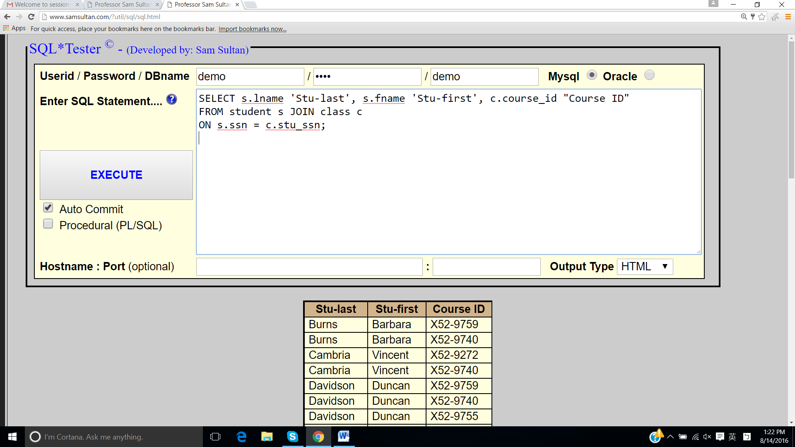

2. List all students, course ids and course descriptions for courses they are currently taking

SELECT s.lname 'Stu-last', s.fname 'Stu-first', c.course_id "Course ID", co.description "Course description"

FROM student s JOIN class c

ON s.ssn = c.stu_ssn

JOIN course co

ON c.course_id = co.course_id;

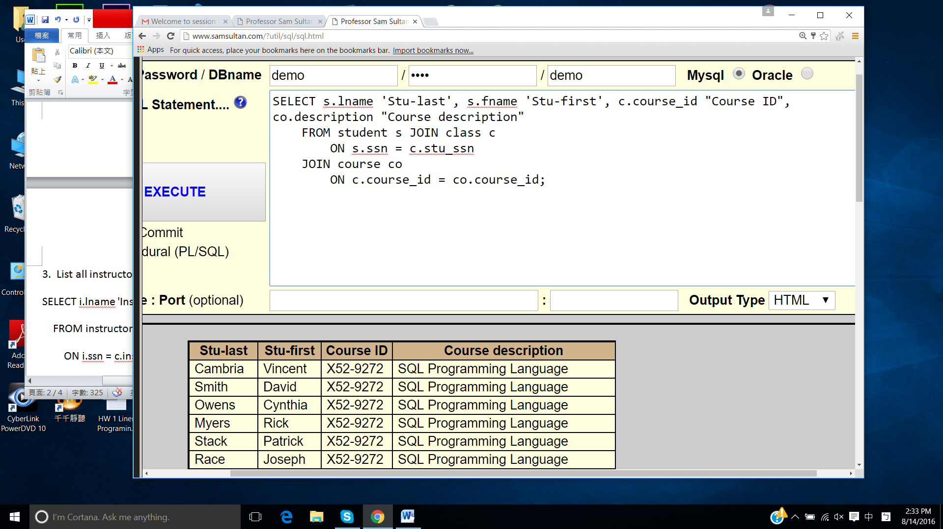

3. List all instructors, and their current students

SELECT i.lname 'Inst-last', i.fname 'Inst-first', s.lname 'Stu-last', s.fname 'Stu-first'

FROM instructor i JOIN class c

ON i.ssn = c.inst_ssn

JOIN student s

ON c.stu_ssn = s.ssn;

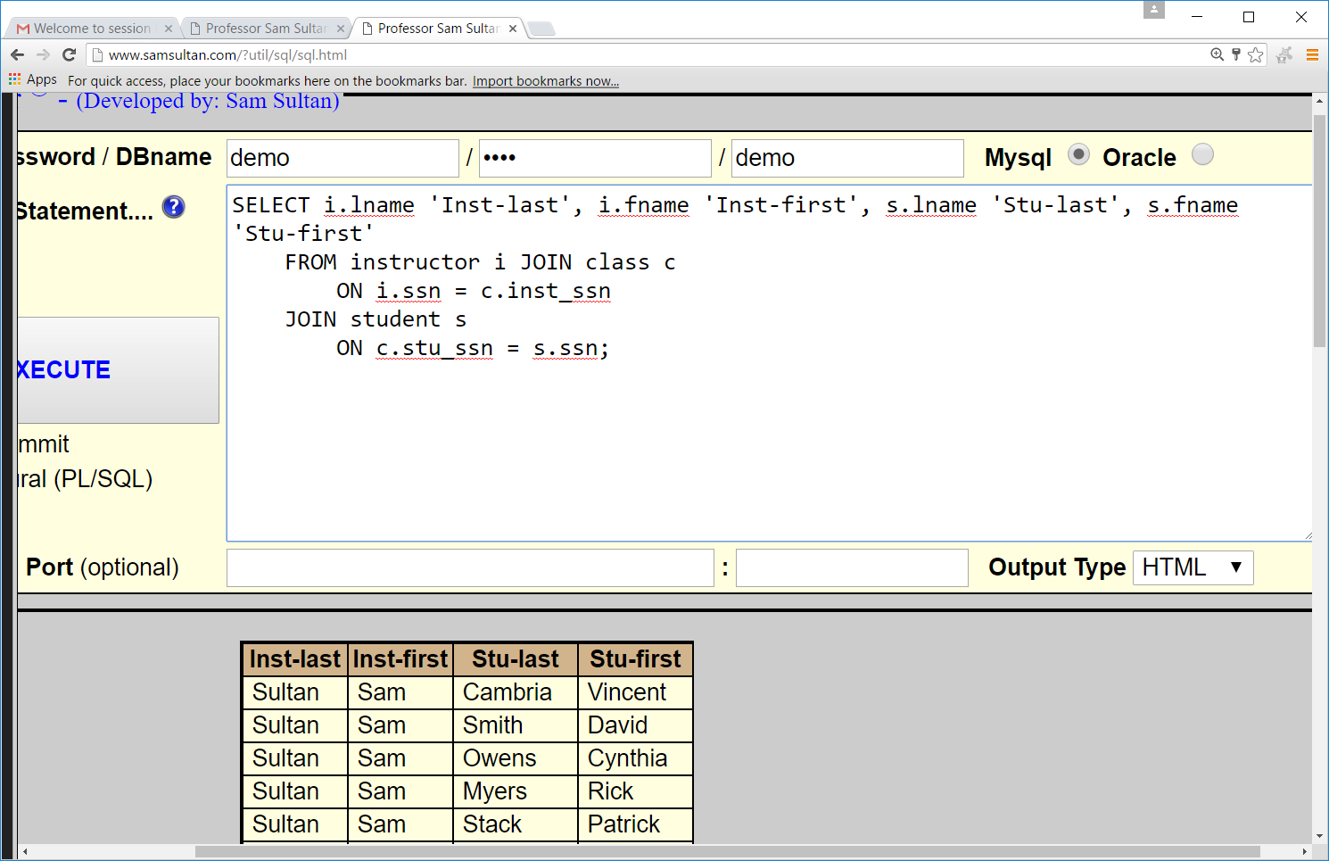

4.

MySQL:

SELECT s.lname 'Stu-last', s.fname 'Stu-first', co.course_id "Course ID", co.description "Course Description"

FROM student s LEFT JOIN class c

ON s.ssn = c.stu_ssn

LEFT JOIN course co

ON c.course_id = co.course_id;

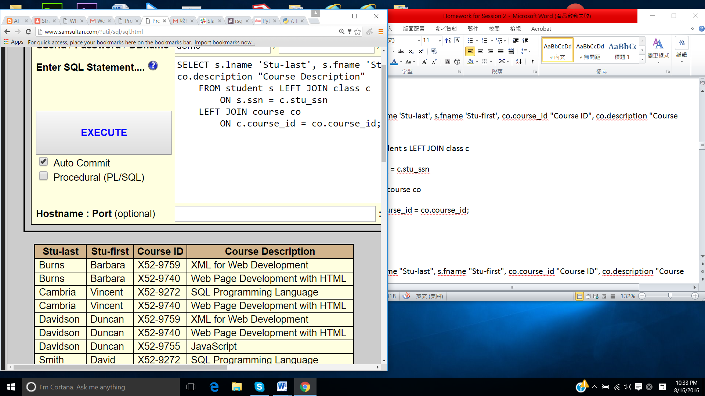

Oracle:

SELECT s.lname "Stu-last", s.fname "Stu-first", co.course_id "Course ID", co.description "Course Description"

FROM student s, class c, course co

WHERE s.ssn = c.stu_ssn(+)

AND c.course_id = co.course_id(+);

5.

Oracle:

SELECT i.lname "Inst-last", i.fname "Inst-first", cl.course_id "Course ID", s.lname "Stu-last", s.fname "Stu-first"

FROM instructor i FULL JOIN class cl

ON i.ssn = cl.inst_ssn

FULL JOIN student s

ON s.ssn = cl.stu_ssn;

MySQL:

SELECT i.lname "Inst-last", i.fname "Inst-first", cl.course_id "Course ID", s.lname "Stu-last", s.fname "Stu-first"

FROM instructor i LEFT JOIN class cl

ON i.ssn = cl.inst_ssn

RIGHT JOIN student s

ON cl.stu_ssn = s.ssn

UNION

SELECT i.lname "Inst-last", i.fname "Inst-first", cl.course_id "Course ID", s.lname "Stu-last", s.fname "Stu-first"

FROM student s LEFT JOIN class cl

ON cl.stu_ssn = s.ssn

RIGHT JOIN instructor i

ON i.ssn = cl.inst_ssn;

Homework Session 3

**1.**

select count(price) as "Number of Courses", sum(price) as "Total Cost of all the Courses",

avg(price) as "Average Price per course"

from course;

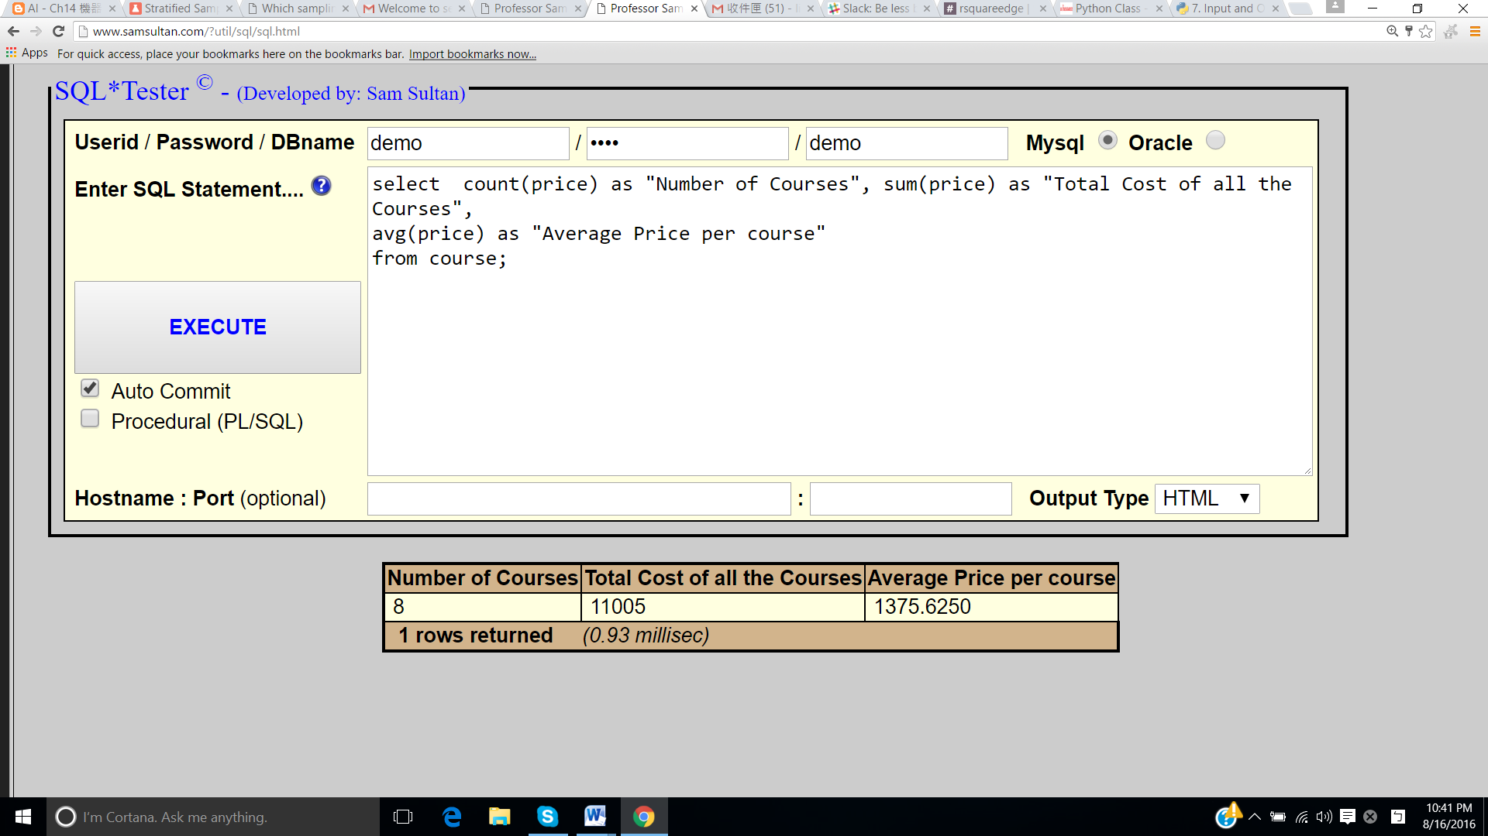

**2.** MySql:

select vendor, description, sum(amount) as "Total Payments", count(amount) as "Number of Payments"

from payment

group by vendor, description with rollup;

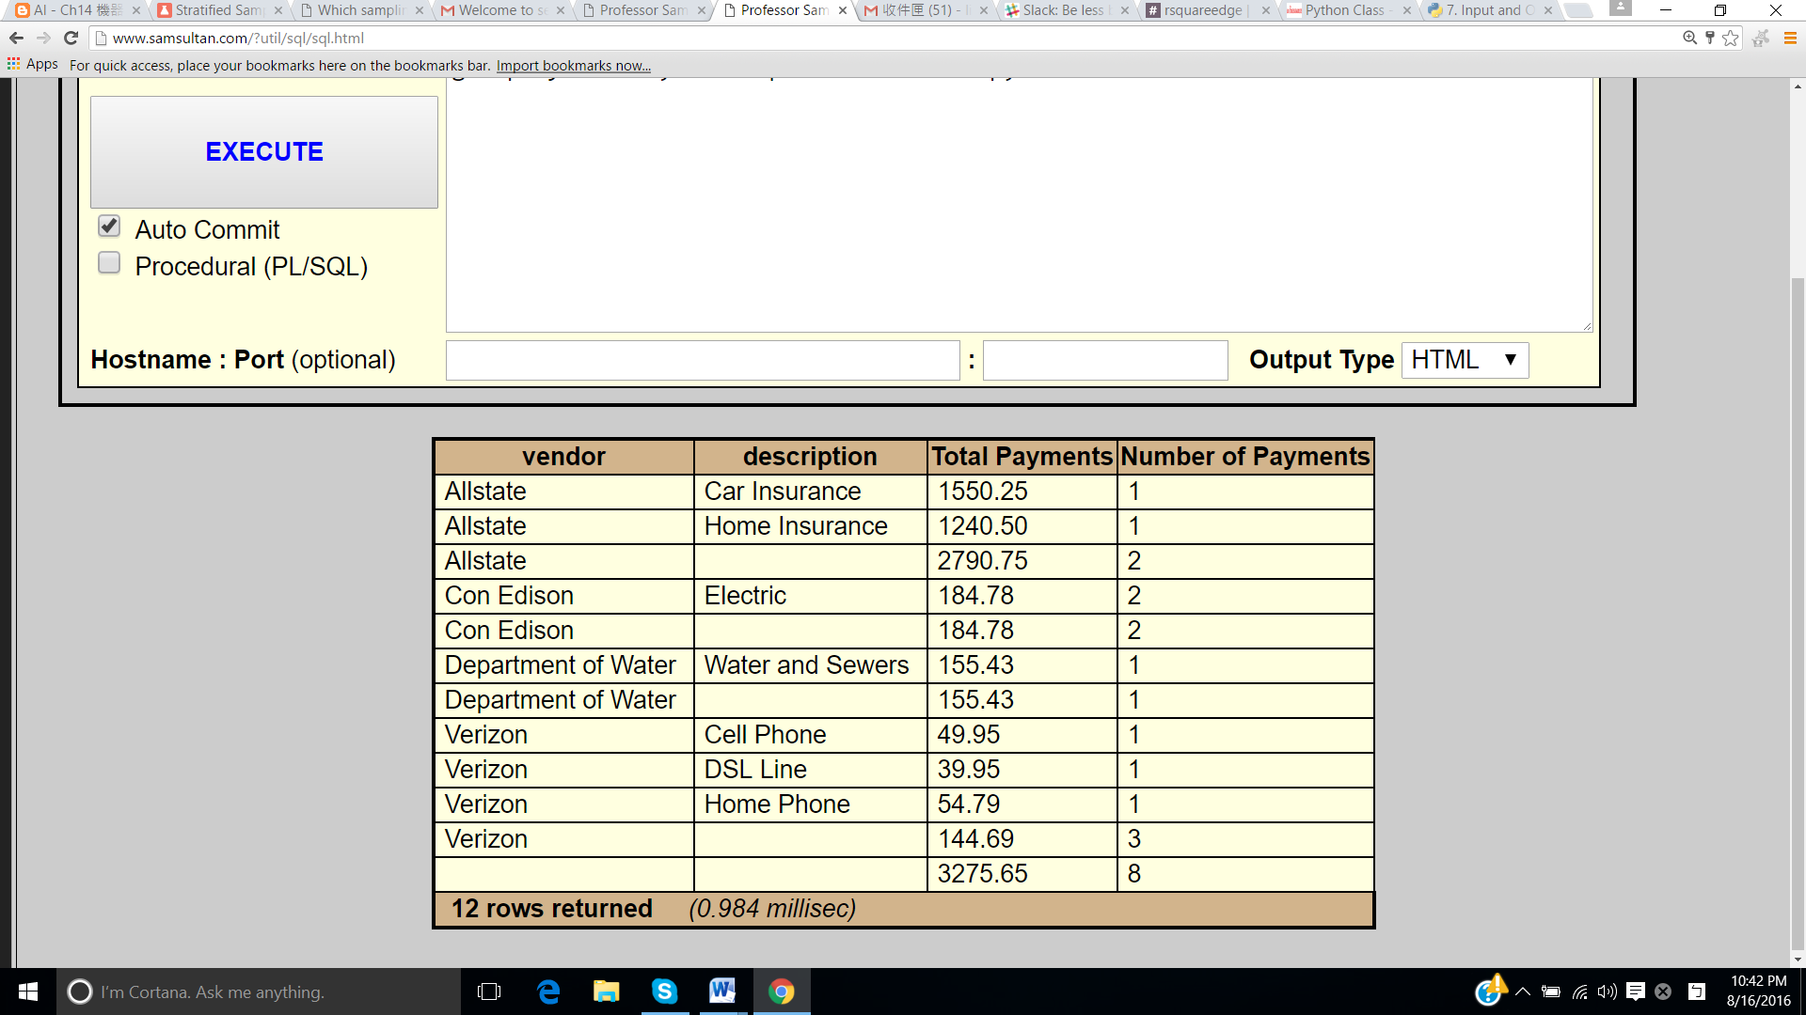

Oracle:

select vendor, description, sum(amount) as "Total Payments", count(amount) as "Number of Payments"

from payment

group by rollup(vendor, description);

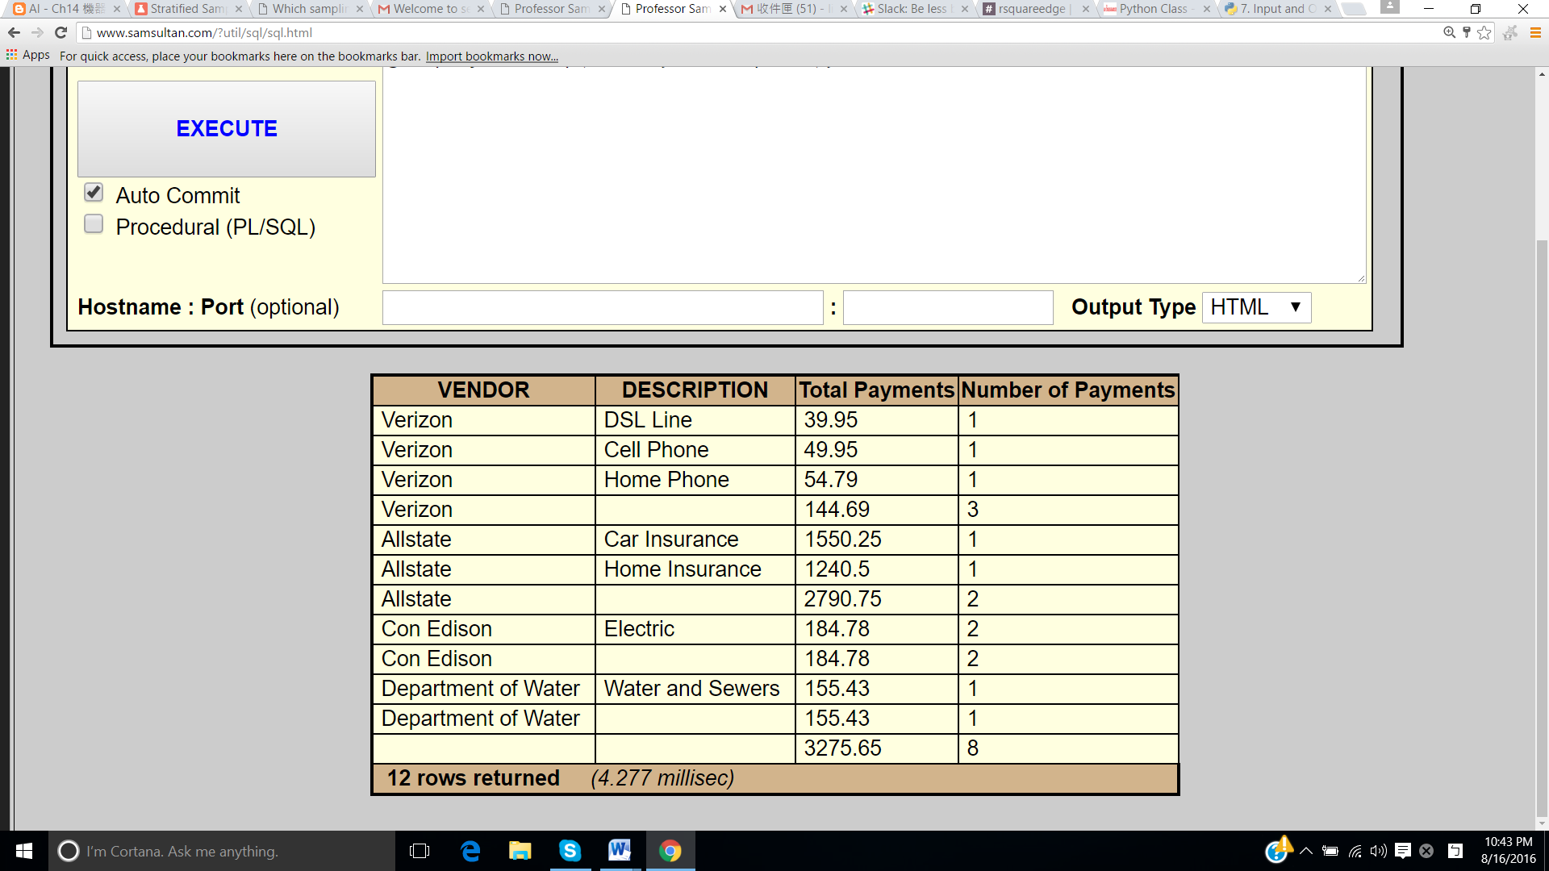

**3.**

select stu_ssn, course_id, count(class_id) as tally

from class

group by stu_ssn, course_id

having count(class_id)>1;

This returns zero rows.

**4.**

select s.lname, s.fname, count(class_id) as "Number of courses"

from student s left join class cl

on ssn=stu_ssn

group by ssn

order by count(class_id) desc, lname, fname;

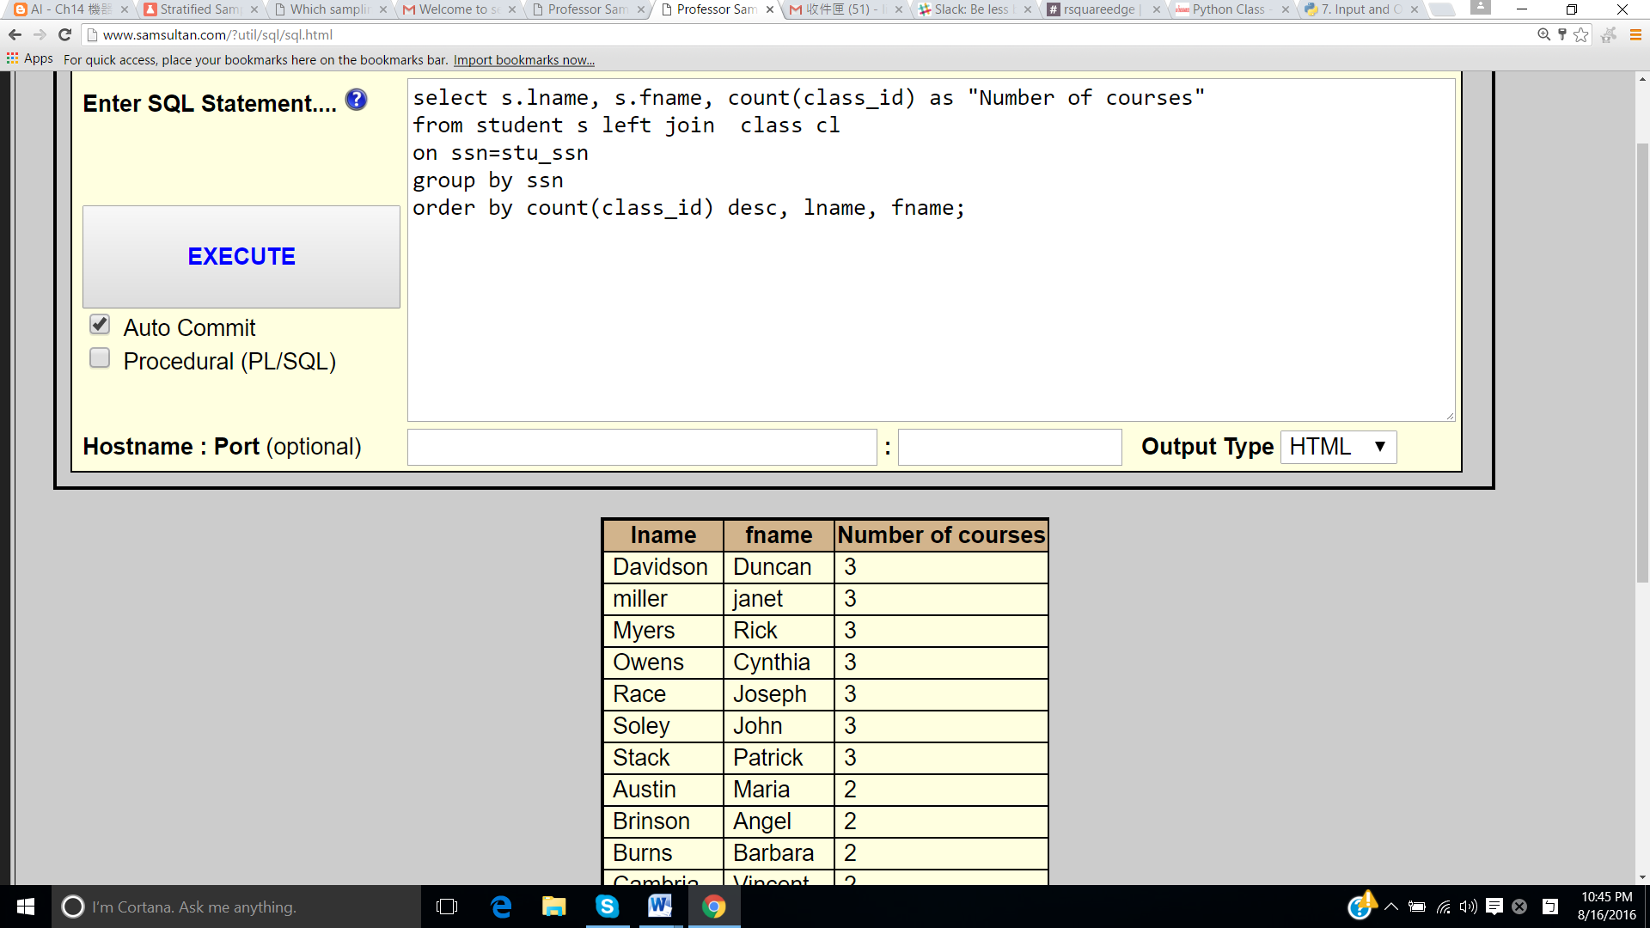

**5.**

select vendor, description, amount

from payment

union

select null, null, sum(amount)

from payment;

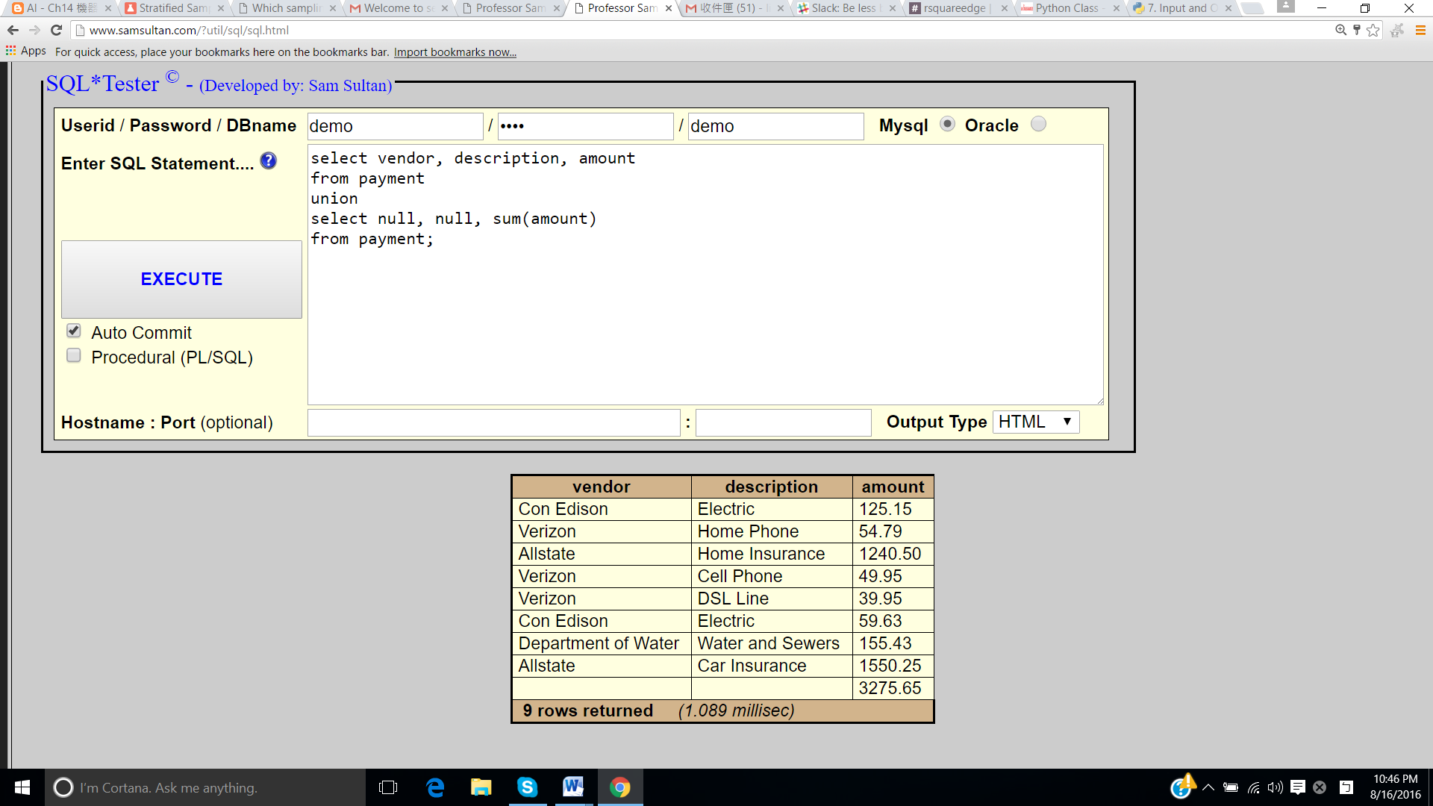

**6**.

select fname, lname, count(class_id) as "Number of classes taught"

from instructor left join class on ssn=inst_ssn

group by fname, lname

having count(class_id)=0;

